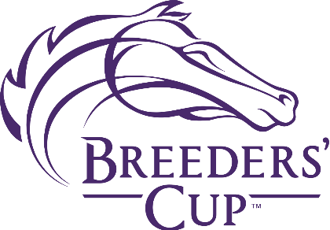

Specialty Cocktails
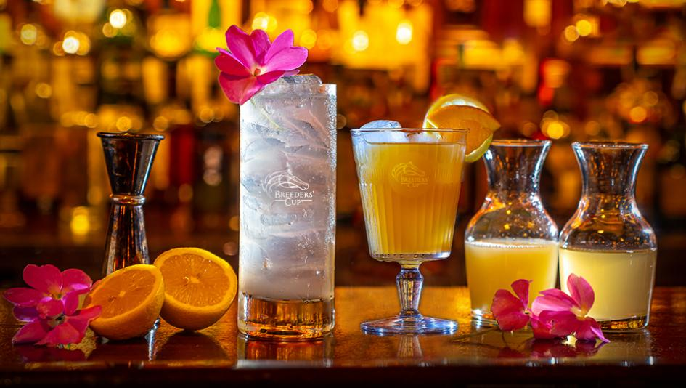
- Torrie Cup Made with Makers Mark Bourbon
$10

- Garland Made with Titos Vodka
$10

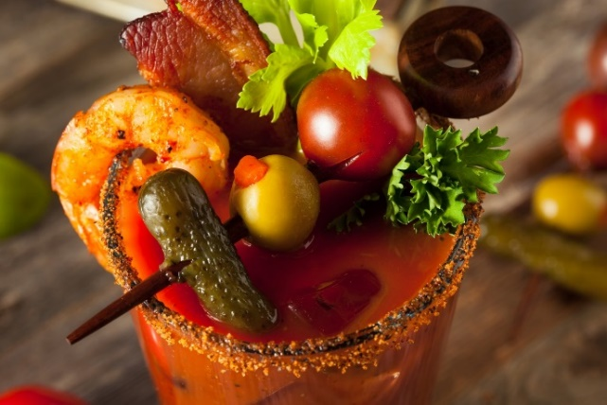
- Loaded Bloody Mary
$13

